Locker 13 Phoenix Comicon Attendees Biographies

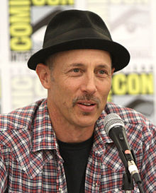
Jon Gries
Jonathan Francis "Jon" Gries (born June 17, 1957) is an American actor, writer and director. He is also credited under the names Jon Francis and Jonathan Gries. He is known for his role in Napoleon Dynamite as Uncle Rico, and more recently as recurring character Roger Linus on Lost. He is also known for his roles in Martin and The Pretender. He also appeared in the movie Running Scared with Gregory Hines and Billy Crystal.
Jon comes to Locker 13 as Archie, the pivotal narrator of the film. As the sage supervisor to new janitor, Skip, he recounts chilling tales that underscore the importance of making the right choice. The recollection includes an aging boxer who is given an opportunity to become a real killing machine, a young man seeking membership in a secret society who experiences an initiation with deadly consequences, a would be suicide shaken to his core by a menacing member of a very special club, and a hit man for hire playing a devious cat and mouse game with three women who have a score to settle.

Jason Spisak
Jason Spisak was born on August 29, 1973. He is known for his work on Piranha (2010), Everything Must Go (2010) and Green Lantern: The Animated Series (2011). Jason’s voice is heavily used in Anime, Animated Movies and TV and on Video Games. You may know him as the voice of Flash in JLA Adventures, as Kid Flash in Young Justice, Silas in The Vampire Diaries, Lux Bonteri in Star Wars: The Clone Wars, Jason Dante in Uncharted: Golden Abyss, Ftokchak in Guild Wars 2, Bartz Klauser in Dissidia 012: Final Fantasy or Tai Kamiya in Digimon Adventure. We personally loved him as the cute little dragon Spyro, which we could not get enough of on the set of Locker 13.
In Locker 13, Jason plays Skip, the new Janitor of the Old Wild West Theme Park, Gunsight Pass. He is shown the ropes by his mentor, Archie and in the process, is told several chilling stories. These stories all come in to play when Skip makes an unsettling discovery within a mysterious Locker 13, and faces a life-or-death decision of his own.
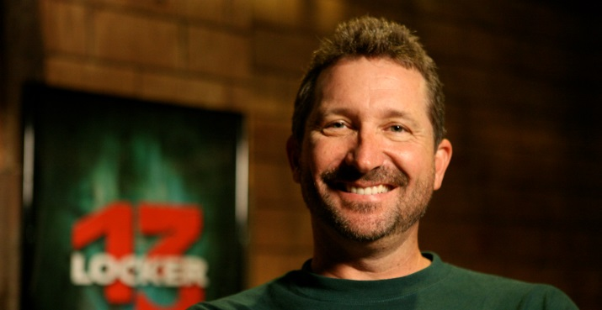
John Waldron
John is a writer and Executive Producer on Locker 13. John is a very hands-on-Producer. Early on in the production when we could not find a specific location we needed for the segment of the film called, The Other Side, John took it on himself to build a small set just outside of Fountain Hills, Arizona on the property of one of our Investors of the film. Slightly over 3 years later he unveiled a whole Wild West Town he had built for the segment!
Here’s the town that John built with his own two hands for Locker 13. I’ve added a stat sheet for the amazing set. It’s still there and has been host to several things since including a few photo shoots, another movie and even a few weddings! John will be available to speak about the journey from script to screen throughout the Phoenix Comicon.
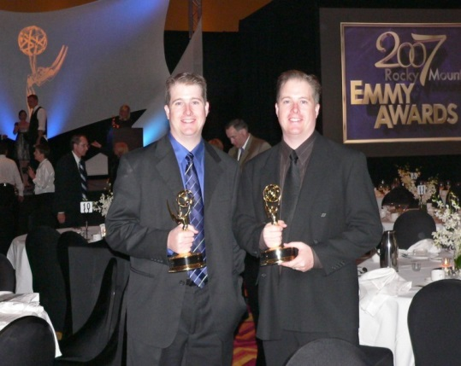
Adam and Donovan Montierth
Twins and filmmakers, Adam and Donovan Montierth opened their production company, Brothers’ Ink Productions in 2004 and has since won over 40 awards at film festivals across the country including an Emmy Award for their touching short film, Reveille in 2007.
Locker 13 is their first full-length feature and they came up with the concept of the thriller anthology when their feature, Capture the Flag, which had James Garner and Louis Gossett Jr. attached, lost it’s funding in 2008. They picked themselves up, determined to make their first feature. Cashing in on all their favors, they tapped all their industry contacts to get this movie made. They’re both Directors, Writers and Executive Producers on Locker 13.

