Locker 13 Movie Press Kit

What is Locker 13?
A thriller anthology feature film, in the style of "The Twilight Zone", comprised of five stories, all revolving around a mysterious locker 13.
What is an anthology?
An anthology is a collection of literary works chosen by the compiler. It may be a collection of poems, short stories, plays, songs, or excerpts. In genre fiction anthology is used to categorize collections of shorter works such as short stories and short novels, usually collected into a single volume for publication.
The term also applies to radio or TV programs, movies, comic books and other such media featuring a variety of different stories. Examples of radio anthologies are Suspense and Escape. Examples of TV anthologies are Alfred Hitchcock Presents, The Twilight Zone, The Outer Limits, American Horror Story, Tales from the Darkside, and Tales from the Crypt, which was not only an HBO series but also a movie anthology, both based on the EC horror-comic anthology. Other examples of anthology films are Four Rooms, Creepshow, Twilight Zone The Movie, and most recently Movie 43.
What is the Synopsis?
Skip, the nighttime janitor in an Old West theme park, delves into the mysteries surrounding an old locker. His sage supervisor recounts chilling tales that underscore the importance of making the right choice. The recollection includes an aging boxer who is given an opportunity to become a real killing machine, a young man seeking membership in a secret society who experiences an initiation with deadly consequences, a would be suicide shaken to his core by a menacing member of a very special club, and a hit man for hire playing a devious cat and mouse game with three women who have a score to settle. The stories suddenly come into play when Skip makes an unsettling discovery and faces a life-or-death decision of his own.

Where was it filmed?
- Los Angeles, California
- Phoenix, Arizona
- A complete full (interiors and exteriors) working Wild West town called Gunsight Pass was built exclusively for Locker 13 just outside of Fort McDowell, Arizona. The set has now been turned into an active fully functional media production backlot.
Who’s in it?
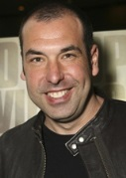
Ricky Schroder – Notable TV Shows and Movies include Silver Spoons, The Champ, NYPD Blue, 24, Scrubs, Lonesome Dove, and Poolhall Junkies.
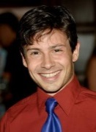
Rick Hoffman - Notable TV Shows and Movies include Suits, Battleship, Samantha Who?, Jake in Progress, and the Hostel movies.
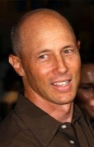
Jason Marsden - Notable TV Shows and Movies include Boy Meets World, Erie Indiana, White Squall, Young Justice, The Goofy Movies and Step by Step.
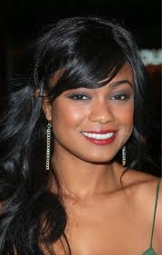
Jon Gries - Notable TV Shows and Movies include Napoleon Dynamite, the Taken movies, Lost, The Pretender and Will Penny.
Tatyana Ali – Notable TV Shows and Movies include The Fresh Prince of Bel Air, The Young and the Restless, The Last Letter, and Dear Secret Santa.
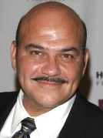
Krista Allen – Notable Movies include The Emmanuelle Series, Liar Liar, Anger Management, The Final Destination, and Fatal Instinct.
Jon Polito - Notable Movies include Miller’s Crossing, Barton Fink, Flags of Our Fathers, The Last Godfather and The Gangster Squad.
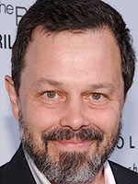
David Huddleston - Notable Movies include Blazing Saddles, Santa Claus the Movie, Crime Busters, The Producers and The Big Lebowski.
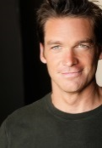
Curtis Armstrong - Notable TV Shows and Movies include The Closer, Revenge of the Nerds, Ray, Risky Business and Better Off Dead.
Bart Johnson - Notable TV Shows and Movies include High School Musical Series, The Saratov Approach, The Christmas Spirit, Vamp U and The Client List.

Who are the key people involved?
Executive Producers:
- John Waldron
- Adam Montierth
- Donovan Montierth
Producers:
- Ricky Schroder
- Jason Marsden
- Matthew Mebane
Directors:
- Adam Montierth
- Jason Marsden
- Bruce Dellis
- Matthew Mebane
- Donovan Montierth
Cinematographer:
- Russell Carpenter
What’s the production company?
Brothers’ Ink Productions out of Phoenix, Arizona. The company has participated in over 40 film festivals across the country, won over 20 awards for their films and screenplays, and sold and optioned several screenplays. Many of the films have aired on TV and their award-winning film "Reveille" has shown on the American Forces Network and the Pentagon Channel. Brothers’ Ink Productions won a Rocky Mountain Emmy® Award for "Reveille" on October 6th, 2007.
Where can I see info about the movie and the trailer?
To view our IMDB page please go: http://www.imdb.com/title/tt1241226/?ref_=nv_sr_1
To view the trailer, please go: http://www.imdb.com/video/withoutabox/vi2491656217?ref_=tt_pv_vi_1

Where can I get more information about the production?
www.locker13.com
www.brothers-ink.com
https://www.facebook.com/pages/Locker-13/118557118336?fref=ts
http://www.linkedin.com/company/3225281?trk=prof-exp-company-name
http://www.imdb.com/company/co0117884/?ref_=fn_al_co_1
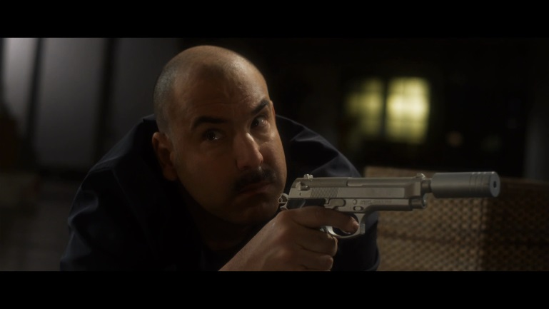
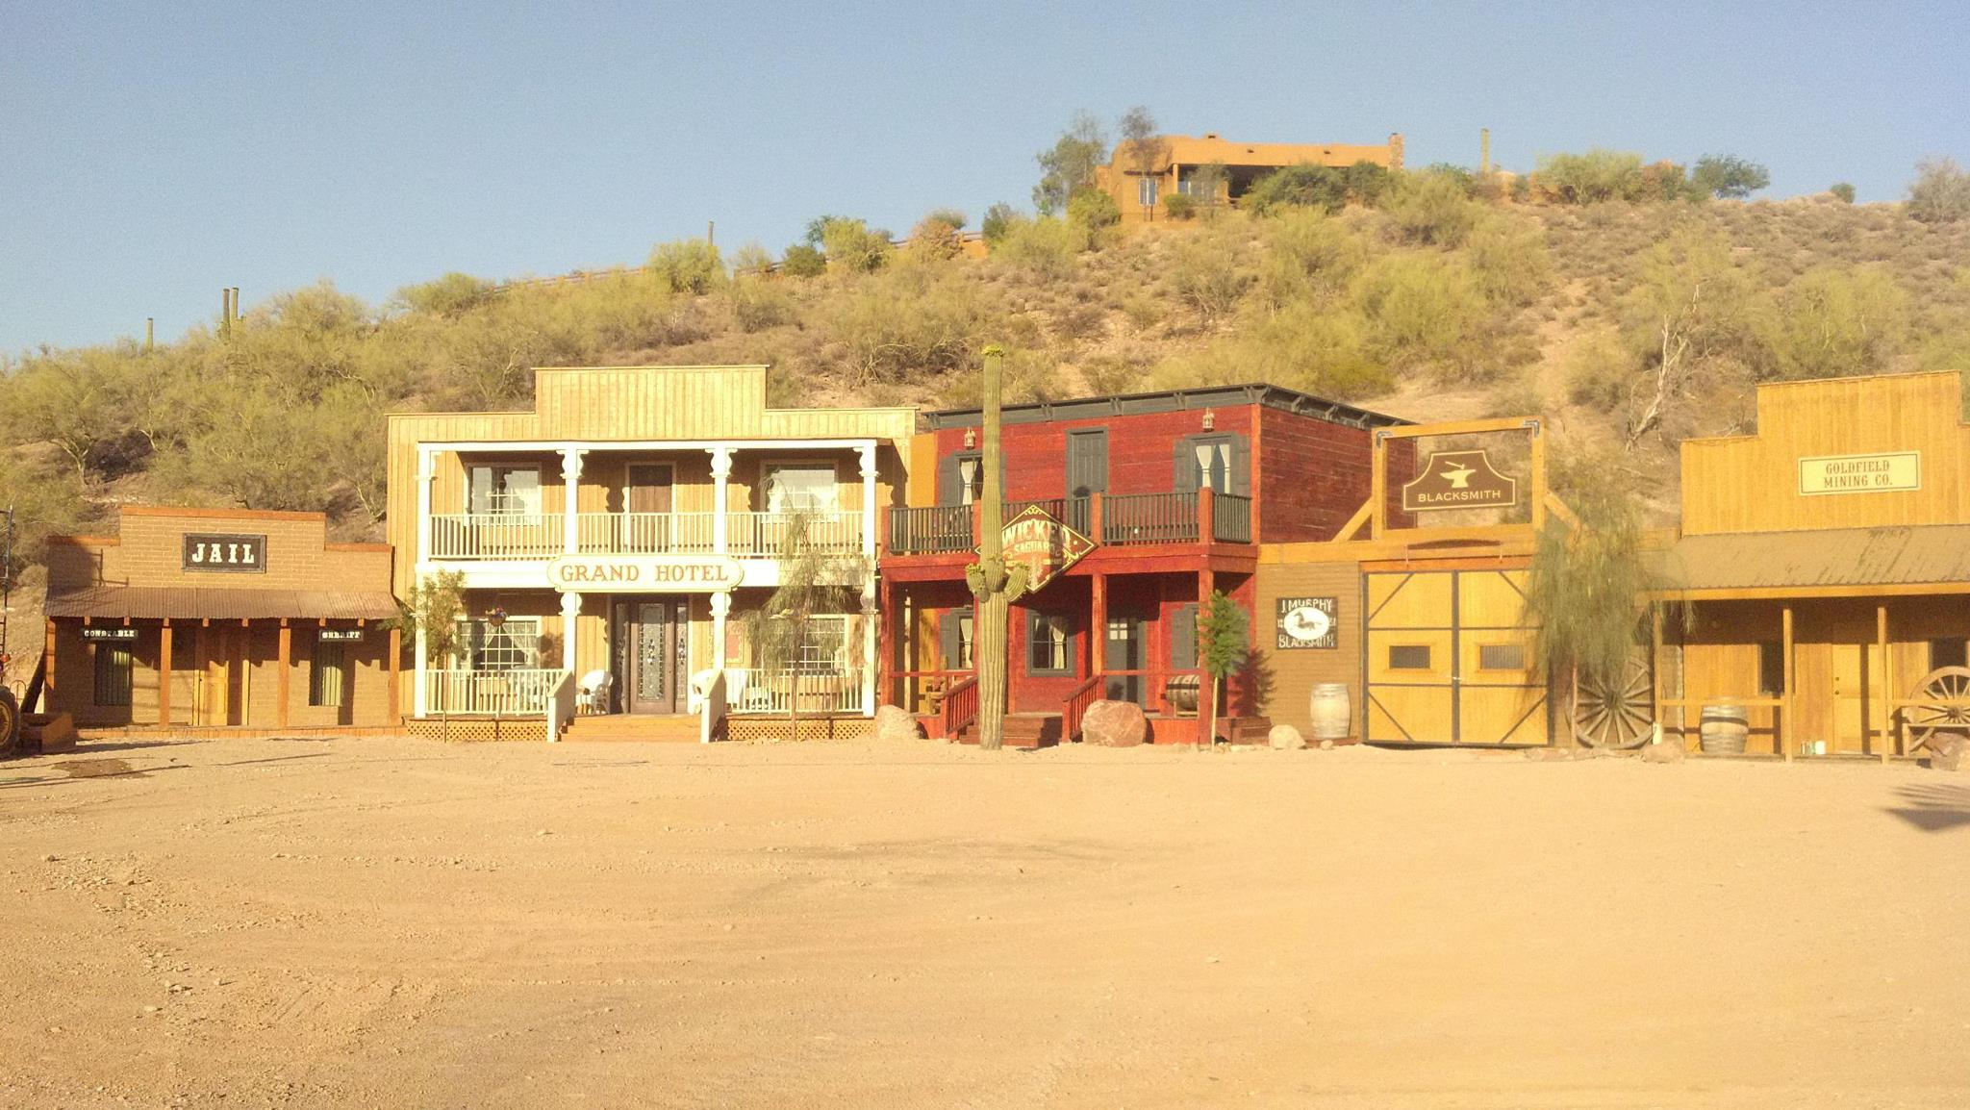
For any questions or more information, please contact John Waldron, Adam Montierth, or Donovan Montierth at info@brothers-ink.com or 480-326-2326.
Gunsight Pass Set Built For Locker 13

